**Loan Bot – A chatbot for Loan Schemes by using NLP &**

**Machine Learning Techniques**

**Dr. Sasidhar Babu Suvanam1, Bharath 2, Naveen Kumar 3, Adil Ijaz4 , Sumanth 5**

1Professor, School of CSE, Presidency University, Bangalore, India.

2,3,4,5B.Tech Final Year Students, Computer Engineering (Artificial Intelligence and Machine Learning),

Presidency University, Bangalore, India.

[sasidharmails@gmail.com](mailto:sasidharmails@gmail.com), [bharaththerock413@gmail.com](mailto:bharaththerock413@gmail.com),[km.naveenkumar03@gmail.com](mailto:km.naveenkumar03@gmail.com),

[sumanthkurapati13@gmail.com](mailto:sumanthkurapati13@gmail.com), [adilijaz2468@gmail.com](mailto:adilijaz2468@gmail.com)

**Abstract**

This paper elucidates the conceptualization, design, and functionality of a specialized chatbot meticulously crafted to deliver pertinent responses to inquiries related to government loans. The purpose of this chatbot is to streamline the process of obtaining information about government loans, thereby saving time for users and alleviating the need for direct visits to financial institutions for inquiries. By receiving user queries, analyzing them intelligently, and furnishing optimal answers, the chatbot serves as an efficient intermediary between individuals and the complex landscape of government loan procedures. This innovative solution not only enhances accessibility to crucial information but also contributes to the overall efficiency of the loan application process. The ensuing sections detail the methodology, design principles, and operational aspects of the developed chatbot, emphasizing its potential to facilitate seamless interactions and enhance user experience in the domain of government loans..

Keywords— Chatbot, loans, insurance , Python, Natural Language Processing, Machine Learning

1. **Introduction**

In the ever-evolving landscape of financial intricacies, the challenges associated with comprehending loan schemes and navigating their intricate processes present formidable obstacles for individuals seeking financial assistance. The quest for critical information often involves traversing through a maze of details, resulting in inefficiencies and delays. Addressing this challenge, this paper introduces the "Loan Bot," an innovative chatbot tailored to address queries related to diverse loan schemes. Through the integration of Natural Language Processing (NLP) and machine learning techniques, Loan Bot stands out as a sophisticated solution, aiming to streamline the interaction between users and the complex domain of loans.

As technology progresses, the transformative impact of integrating NLP and machine learning into chatbot systems becomes increasingly evident. This paper explores the development and functionality of Loan Bot, shedding light on how NLP algorithms and machine learning techniques empower the chatbot to intelligently interpret user queries, discern the subtleties of loan-related inquiries, and deliver tailored and precise responses.

The primary goal of Loan Bot is to alleviate the challenges traditionally associated with accessing information about loan schemes. Through its user-friendly interface, individuals can pose questions, seek guidance, and receive comprehensive information without the need to physically visit financial institutions. This not only saves valuable time for users but also contributes to a more efficient and accessible dissemination of information in the realm of loans.

Loan Bot's significance extends beyond information retrieval; it fundamentally transforms the user experience in navigating the complexities of loan processes. By harnessing the capabilities of NLP and machine learning, the chatbot becomes adept at understanding contextual intricacies, ensuring users receive not only accurate but also contextually relevant information. This paper elucidates the intricate design principles, methodologies, and technical foundations underpinning the development of Loan Bot, positioning it as a cutting-edge solution in the domain of financial assistance.

In the subsequent sections, we delve into the architecture of Loan Bot, the integration of NLP algorithms, and the user interaction workflow. Additionally, we highlight ethical considerations and potential future enhancements, providing a comprehensive overview of the synergistic integration of NLP, machine learning, and chatbot technologies in the context of government loan schemes.

1. **Methodology**

In the Requirements Gathering phase, Detailed user research, interviews and the Team focus on carefully defining and analyzing user expectations. We will also cover the complexity of the loan process by explaining basic needs and user preferences. This understanding will form the basis for the next stage of development. In the Design and Architecture phase, we will carefully prepare the structure of the chatbot, carefully design the user interface, dialogue and backend process. Python will be chosen as the main language, taking advantage of its simplicity and versatility, while NLP technologies such as NLTK or spaCy will be integrated to improve the chatbot's ability to understand natural language.

Shift During the Development phase, the chatbot will be developed using Python and best practices in coding and software development will be followed. Machine learning algorithms will be introduced to help chatbots understand user requests and provide personalized loan recommendations. Growth is iterative and results in continuous improvement. The next API integration steps will involve working with service providers to seamlessly integrate their APIs using Python applications. This integration will allow users to apply for loans directly via the chatbot.

The Testing phase will be very strict with usability tests, functional tests and functional tests. This comprehensive testing is designed to identify and fix problems with functionality, accuracy, and usability. Once testing is complete, the chatbot will move on to the *deployment* phase, where it will be deployed to various platforms such as web and mobile applications using Python-compatible deployment tools.

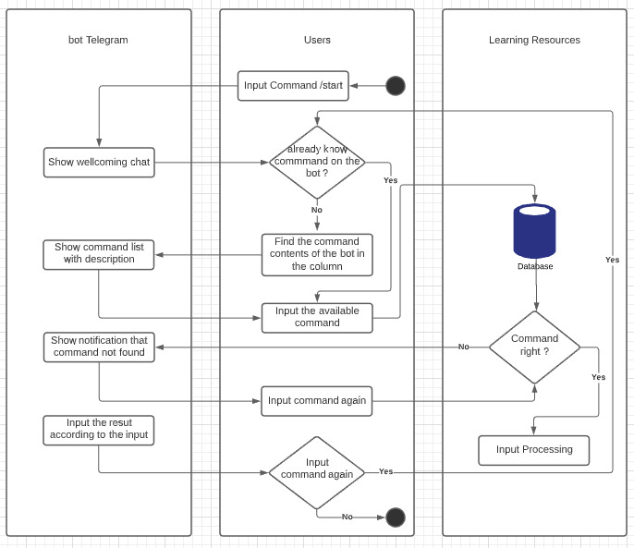

**Fig. 1 Flow Chart of Loan Bot**

After deployment, the focus shifts to maintenance and updates with constant feedback from users. Continuous monitoring of user feedback will lead to the implementation of updates and improvements to the chatbot algorithm and user interface. *Agile development* methods should be decisively adopted in the process, with regular sprints to ensure changes in user needs and effective collaboration with the construction team. This nuanced approach aims to not only improve the lending process, but also ensure the longevity and flexibility of the chatbot to meet the changing needs of users.

1. **System design**

**A. Input Design for Loan Bot**

* Purposeful Interaction: Design inputs for specific purposes such as user queries related to loan schemes.
* Accuracy and Completion: Ensure accurate and complete information is provided by users.
* Ease of Use: Create an easy and straightforward input process for user convenience.
* User Focus: Focus on user attention, consistency, and simplicity in the input process.
* NLP Integration: Leverage Natural Language Processing (NLP) and other methods for understanding diverse user queries effectively.

**B. Objectives for Input Design in Loan Bot**

* User-Friendly Methods: Design intuitive and user-friendly input methods, including NLP.
* Reduction of Redundancy: Streamline the interaction process by reducing unnecessary or redundant input volumes.
* Effective Data Capture: Implement effective data capture methods, interpreting user queries accurately.
* Tailored Interaction: Develop input data records, chat interfaces, and user interaction screens tailored for seamless communication.
* Validation Checks: Implement validation checks and effective input controls to ensure accuracy and security.

**C. Output Design for Loan Bot**

* Purpose-Aligned Outputs: Develop outputs that align with the intended purpose, delivering relevant and accurate information.
* User-Centric Responses: Meet end-user requirements by providing clear, concise, and directly relevant responses.
* Appropriate Output Quantity: Deliver appropriate quantities of output based on the complexity and nature of user queries.
* User-Friendly Formatting: Format output in a user-friendly manner, ensuring a seamless and personalized experience.
* Timely Delivery: Ensure timely delivery of responses to facilitate informed decision-making for users seeking information on loan schemes.

1. **Result and Discussion**

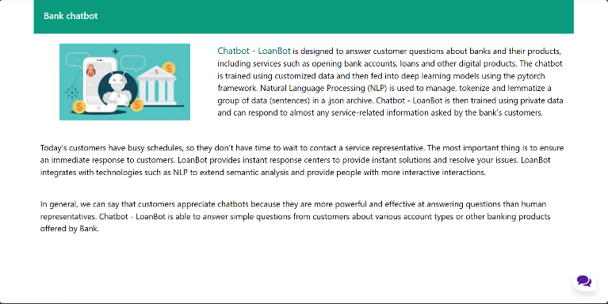

**Fig. 2 Home Page**

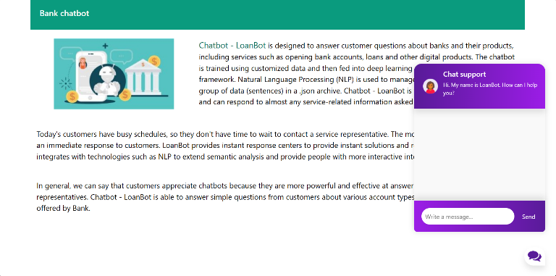

**Fig. 3 Chatbot Page**

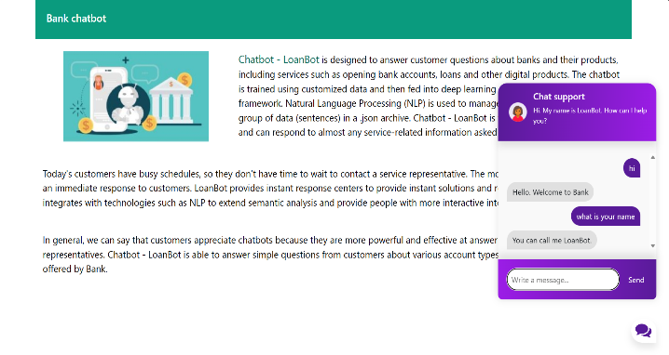

**Fig. 4 Chatbot interaction**

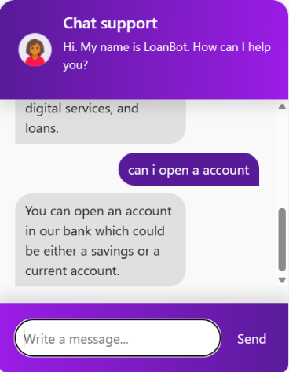 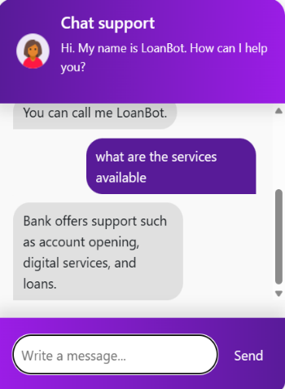

**Fig.5 Result 1**

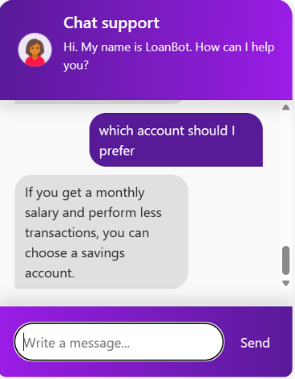 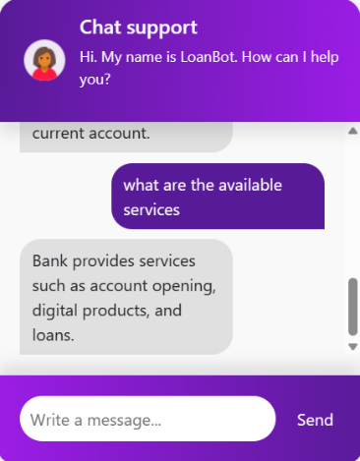

**Fig.6 Result 2**

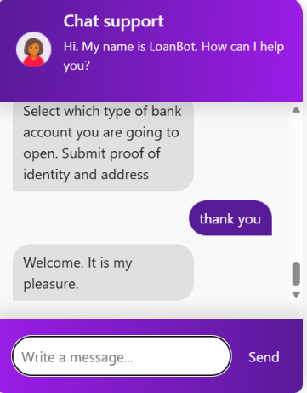 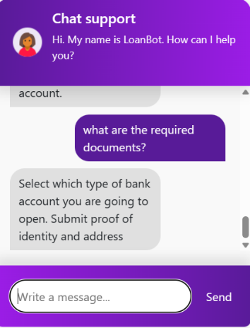

**Fig.7 Result 3**

1. **Future Work**

In advancing the capabilities of the Loan Bot, a chatbot designed for loan schemes utilizing Natural Language Processing (NLP) and machine learning, several future work directions can be explored. To enhance user interaction, there is a need to refine the chatbot's natural language understanding, sentiment analysis, entity recognition, and intent classification. The development of machine learning algorithms is crucial for providing dynamic and personalized loan recommendations, taking into account individual financial profiles and factors such as credit score, income, and spending habits. Additionally, incorporating advanced models for risk assessment and fraud detection is essential to ensure the security and reliability of loan processes. Transparency and user trust can be improved by implementing features that explain the rationale behind the chatbot's decisions. Multi-channel integration, real-time market analysis, and compliance with regulatory standards are imperative for a seamless and legally compliant user experience. Furthermore, the chatbot should facilitate user education in financial literacy, offer a feedback mechanism for continuous improvement, support multiple languages, and prioritize user privacy and data security. These enhancements collectively contribute to the evolution of the Loan Bot into a sophisticated and user-centric tool, delivering informed financial guidance while adhering to industry standards.

1. **Conclusions**

In conclusion, the creation and deployment of the Loan Bot, a chatbot tailored to address inquiries about government loan schemes using a combination of Natural Language Processing (NLP) and machine learning techniques, represent a substantial advancement in utilizing technology to streamline financial information dissemination. The integration of NLP and machine learning enables the chatbot to intelligently understand and respond to user queries, providing a user-friendly alternative to traditional methods of obtaining loan-related information.

The main objective of the Loan Bot is to save users time by delivering prompt and accurate responses to their queries, eliminating the need for direct visits to banks or financial institutions. This not only enhances user convenience but also contributes to the overall efficiency of the loan application process. Through the application of machine learning techniques, the chatbot continually refines its understanding and response patterns, ensuring adaptive and accurate interactions with users.

By harnessing the capabilities of NLP and machine learning, the chatbot effectively interprets complex language nuances, ensuring users receive the most relevant and precise information tailored to their specific inquiries. Moreover, the implementation of the Loan Bot aligns with the broader trend of digitization and automation in the financial sector, introducing a new era of accessibility and user-friendly access for individuals seeking information on government loan schemes.

The success of the chatbot lies in its ability to bridge the gap between users and the intricate world of loan procedures, offering a seamless and technology-driven avenue for obtaining crucial information. As technology advances, the Loan Bot serves as evidence of the potential of NLP and machine learning-powered chatbots in transforming how individuals interact with financial services. It not only demonstrates the practical application of artificial intelligence in simplifying complex processes but also underscores the importance of user-centric design in developing innovative solutions. The Loan Bot, with its emphasis on precision, efficiency, and user satisfaction, sets the stage for future advancements in the realm of financial assistance and information dissemination.

**Acknowledgment**

We express our gratitude to all those who have contributed to the successful development of the "Loan Bot – A chatbot for Loan Schemes by using NLP and Machine Learning" project. This endeavor would not have been possible without the collective effort and support of various individuals and resources.

We express our sincere gratitude to our supervisor, whose guidance and expertise have been invaluable throughout the entire research and implementation process. Their insights and encouragement have played a crucial role in shaping the project into its final form.

we also appreciate the assistance and cooperation received from our group members, who worked diligently to ensure the seamless integration of Natural Language Processing (NLP) techniques into the chatbot, enhancing its functionality and responsiveness.

Furthermore, we are grateful to Presidency University for providing the necessary infrastructure and resources essential for the execution of this project. The conducive environment fostered a collaborative spirit, contributing to the project's success.

We extend our thanks to the participants who provided valuable feedback during the testing phase, helping refine the chatbot's performance and user experience.

Finally, we appreciate the encouragement and guidance provided by our mentors, advisors, and colleagues throughout the research process. Their expertise and constructive feedback have played a crucial role in refining our methodology and interpreting the results.

This project represents a collective effort, and we are thankful for the collaboration and support that have made it possible.

**References**

[1] Yingying Gao and Marijn Janssen. 2020. Generating value from government data using AI: An exploratory study. In 19th IFIP WG 8.5 International Conference on Electronic Government. Springer, 319–331.

[2] Rizk, Y., Isahagian, V., Boag, S., Khazaeni, Y., Unuvar, M.,Muthusamy, V. and Khalaf, R., 2020, September. A Conversational Digital Assistant for Intelligent Process Automation. In International Conference on Business Process Management (pp. 85-100).

[3] Adamopoulou, Eleni, and Lefteris Moussiades. “An overview of chatbot technology.” IFIP International Conference on Artificial Intelligence Applications and Innovations. Springer, Cham, vol. 584, 2020.

[4] O. Hourrane, H. Ouchra, A. Hafsa, EL. Eddaoui, H. Benlahmar and O. Zahour, "Towards a Chatbot for educational and vocational guidance in Morocco: Chatbot E-Orientation", International Journal of Advanced Trends in Computer Science and Engineering, vol. 9, no. 2, pp. 2479-2487, April 2020.

[5] R. Rajkumar and V. Ganapathy, "Bio-Inspiring Learning Style Chatbot Inventory Using Brain Computing Interface to Increase the Efficiency of E-Learning", IEEE Access, vol. 8, pp. 67377-67395, 2020.

[6] M. Dharani, J. V. S. L. Jyostna, E. Sucharitha, R. Likitha and S. Manne, "Interactive Transport Enquiry with AI Chatbot", 2020 4th International Conference on Intelligent Computing and Control Systems (ICICCS), pp. 1271-1276, 2020.

[7] Ramires Hernández P, Valle-Cruz D and Mendoza Méndez R.(2022). Review on the Application of Artificial Intelligence-Based Chatbots in Public Administration. Handbook of Research on Applied Artificial Intelligence and Robotics for Government Processes. 10.4018/978-1-6684-5624-8.ch007. (133-155).

[8] Collins, Coty M. “Chatbot development and deployment platform.” US Patent No. 10,817,265. October 27 2020.

[9] Muhammad, Aliv Faizal, et al. “Developing English Conversation Chatbot Using Dialogflow.” 2020 International Electronics Symposium (IES). IEEE, pp. 468–475, 2020.

[10] Sharma, Rakesh Kumar, and Manoj Joshi. “An Analytical Study and Review of open Source Chatbot framework, RASA.” International Journal of Engineering Research and , vol.9, no.06 (2020).

[11] Thosani, Parth, et al. “A Self Learning Chat-Bot from User Interactions and Preferences.” 2020 4th International Conference on Intelligent Computing and Control Systems (ICICCS). IEEE, pp. 224-229, 2020.

[12] B. Sonawane, A. Ombase, P. Rajmane, and D. Kamble, “Chatbot for Institutional Purpose,” no. 07, pp. 585–601, 2020.

[13] Nuruzzaman, Mohammad, and Omar Khadeer Hussain. “IntelliBot: A Dialogue-based chatbot for the insurance industry.” Knowledge-Based Systems, vol. 196, 2020.

[14] Aradhana Bisht, Gopan Doshi, Bhavna Arora, and Suvarna Pansambal, “Multilingual CHATBOT with Human Conversational Ability”, vol. 13, no. 1, pp. 138–146, 2020.

[15] Nagarhalli, Tatwadarshi P., Vinod Vaze, and N. K. Rana. “A Review of Current Trends in the Development of Chatbot Systems.” 2020 6th International Conference on Advanced Computing and Communication Systems (ICACCS). IEEE, pp. 706-710, 2020.

[16]Vijayalakshmi Y, Manimegalai, Suvanam Sasidhar Babu,” Accurate Approach towards Efficiency of Searching Agents in Digital Libraries using Keywords", Journal of Medical Systems (SPRINGER) 43:164 <https://doi.org/10.1007/s10916-019-1294-5>, 1st May 2019, *Impact Factor: 5.23 – Q1 Rated Journal.*  <https://dl.acm.org/toc/jmsy/2019/43/6>

[17] Teena Jose, Suvanam Sasidhar Babu – “Detecting Spammers on Social Network Through Clustering Technique”, Journal of Ambient Intelligence and Humanized Computing (SPRINGER)”, pp-1-15, <https://doi.org/10.1007/s12652-019-01541-6>, *Impact Factor: 7.104 ( 2020 ) – Q1 Rated Journal.*

[18] Dijesh P, Suvanam Sasidhar Babu, Yellepeddi Vijayalakshmi – “Enhancement Of E-Commerce Security Through Asymmetric Key Algorithm”, Computer Communications, ELSEVIER, Science Direct, Volume153, Pages 125-134, 2020, [https://doi.org/10.1016/j.comcom.2020.01.033](https://doi.org/10.1016/j.comcom.2020.01.033#_blank)

[19] Y. Vijayalakshmi, P. Manimegalai, GKD Prasanna Venkatesan, Dr. S. Sasidhar Babu “Contextual Information Retrieval in Digital Library and Research Over Current Search Engines” Jour of Adv Research in Dynamical & Control Systems, Vol. 11, 01- ISSN 1943-023X, 2019, pp 790-793.

[20] Bindhia K.F, Yellepeddi Vijayalakshmi, Dr.P. Manimegalai & Suvanam Sasidhar Babu, Classification using Decision Tree Approach towards Information Retrieval Keywords Techniques and A Data Mining Implementation using WEKA data set, International Journal of Pure and Applied Mathematics,ISSN: 13118080 (printed version), Volume 116 No. 22 2017, 19-29, ISSN: 1311-8080 (printed version); ISSN: 1314-3395 (on-line version) <http://acadpubl.eu/jsi/2017-116-13-22/issue22.html> <https://www.scopus.com/sourceid/19700182690>

[20] Yellepeddi Vijayalakshmi, Neethu Natarajan, Dr.P. Manimegalai and Dr. Suvanam Sasidhar Babu, “Study On Emerging Trends In Malware Variants” , for publication in IJPAM International Journal of Pure and Applied Mathematics(SCOPUS), ISSN 1314-3395.Volume 116 No. 22 2017pages 479-489, ISSN: 1311-8080 (printed version); ISSN: 1314-3395 (on-line version)

<http://acadpubl.eu/jsi/2017-116-13-22/issue22.html> <https://www.scopus.com/sourceid/19700182690>

[21] Neethu Natarajan, Teena Jose, Dr. Suvanam Sasidhar Babu, “Secret Data Hiding Using Image Segmentation andLeast Significant BIT (LSB) Insertion Steganography” for publication in IJPAM International Journal of Pure and Applied Mathematics (SCOPUS), ISSN 1314-3395 Volume 117 No. 15, 2017, p.p 527-534, ISSN: 1311-8080 (printed version); ISSN: 1314-3395 (on-line version) <https://www.scopus.com/sourceid/19700182690>

[22] Hridya V Devaraj, Anju Chandran, Dr. Suvanam Sasidhar Babu “MANET Protocols: Extended ECDSR Protocol for Solving Stale Route Problem and Overhearing” IEEE proceedings of the 2016 International Conference on Data Mining and Advanced Computing (SAPIENCE), 2016. <http://ieeexplore.ieee.org/stamp/stamp.jsp?arnumber=7684168> **DOI:** [10.1109/SAPIENCE.2016.7684168](http://dx.doi.org/10.1109/SAPIENCE.2016.7684168#_blank)

[23] Divya. D, Dr. Suvanam Sasidhar Babu “Methods to detect different types of outliers” IEEE proceedings of the 2016, International Conference on Data Mining and Advanced Computing (SAPIENCE), 2016 <http://ieeexplore.ieee.org/stamp/stamp.jsp?arnumber=7684114> **DOI:** [10.1109/SAPIENCE.2016.7684114](http://dx.doi.org/10.1109/SAPIENCE.2016.7684114#_blank)

**Electronic ISBN:** 978-1-4673-8594-7 **Print on Demand (PoD) ISBN:** 978-1-4673-8595-4

[24] Sajay K.R, Dr. Suvanam Sasidhar Babu“A Study of Cloud Computing Environments for High Performance Applications”, IEEE proceedings of the 2016 International Conference on Data Mining and Advanced Computing (SAPIENCE), 2016. <http://ieeexplore.ieee.org/document/7684127/>

**DOI:** [10.1109/SAPIENCE.2016.7684127](http://dx.doi.org/10.1109/SAPIENCE.2016.7684127#_blank), **Electronic ISBN:** 978-1-4673-8594-7 **Print on Demand (PoD) ISBN:** 978-1-4673-8595-4

[25] Teena Jose, Vijayalakshmi, Yellepeddi, Dr. Sasidhar Babu Suvanam and Dr. Mani Megalai “Cyber Crimes in India: A Study”, IEEE proceedings of the SCOPES 2016.**Date Added to IEEE *Xplore*:**26 June 2017 **DOI:**[10.1109/SCOPES.2016.7955584](https://doi.org/10.1109/SCOPES.2016.7955584#_blank) <http://ieeexplore.ieee.org/document/7955584/> Pages: 960 - 965